**Jupyter Notebook Instructions**

Start by typing at the command prompt: >jupyter notebook



Python cell

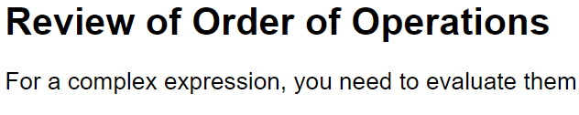

Text cell

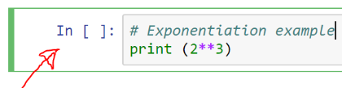

Select Python cell



Run selected cell

Add below selected cell



Save File

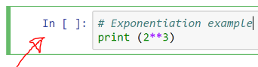**Remove**

1. **Select**
2. **Cut** 

**Cut and Paste**

1. **Select**
2. **Cut** 
3. **Paste** 

** Copy & Paste**

1. **Select**
2. **Copy** 



1. **Paste**

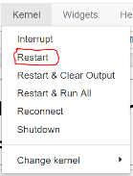

Restart if the computer is stuck for a long time.